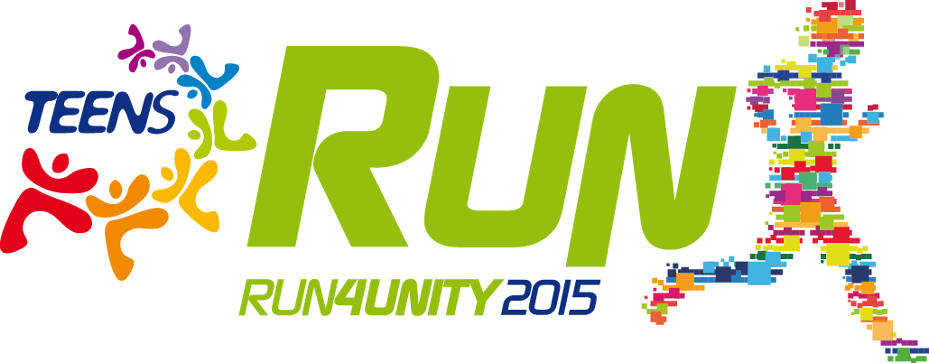

RUN4UNITY May 3, 2015

How to participate in the 'Edition 2015? By submitting the name of the city, the schedule and the venue of the event with a brief description of what you plan to do, email to: centro.rpu@focolare.org
It is important to give us also the name and email of the contact person.

> MY TOWN PARTICIPATE
From now on in www.run4unity.net you can share pictures of the preparations and then the Event itself, this will make visible the cities and groups participating in Run4Unity.

How? To keep us connected we chose to use the hashtag (#).
For those who are not familiar with this method, we explain how it works:

1. Put your photos on any social network (Facebook, Twitter, Flickr, Instagram, Youtube, Google+ etc.). Remember that to public the photos, you have to put the privacy as "global / public" instead of "just friends";
2. Write # run4unity in the comment to the photo;
3. Write the name of your city (eg #rome #sydney #chicago);
4. Everything will appear later in the page:
http://www.run4unity.net/2015/hashtag-run4unity/

> WE LIVE THE GOLDEN RULE
A race between all. Let's see which of the participating cities will have achieved more hashtag for peace. We share right now, but also after the May 3, the experiences about the Golden Rule to spread this way of life that builds peace.

The method of posting is the same:
1. Write the moments of life lived in the Golden Rule on any social network (Facebook, Twitter, Flickr, Instagram, Youtube, Google+ etc.). Remember that making public the photos, you have to put the privacy was "global / public" instead of "just friends";
2. Write #run4unity#(name of your city) in the comment of the photo;
3. Dedicate this experience to a country at war, adding a hashtag with the name of that country, for example: # 4siria or #4nigeria. So that together with the “Time out”, we can give them our support and make them feel less alone.
4. The various experiences will appear on the website: www.run4unity.net

Useful material can be found on www.run4unity.net

• the text for the Time Out;
• experiences on the Golden Rule;
• the experiences of young people living in countries at war. We remind you that in the Link-Up of February, there are some news from countries at war that can be used.

The Center of the Teens for Unity

